STEP 4 – File generation for Water shape
4.0-) Open your raw.bil file.
4.1-) To generate the water shape we need to create a intermediate SHP file with all map area.
To do this: Click on DIGITIZER TOOL on main toolbar. Click OK on next info window
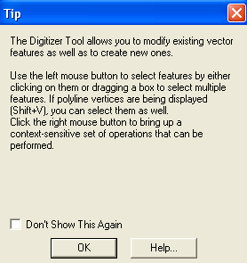

Move the mouse crosshair on map area and click RIGHT MOUSE BUTTON. A popup menu will appear.
Select CREATE AREA / POLYGON FEATURES – CREATE RECTANGULAR / SQUARE (SPECIFY COORDINATES)
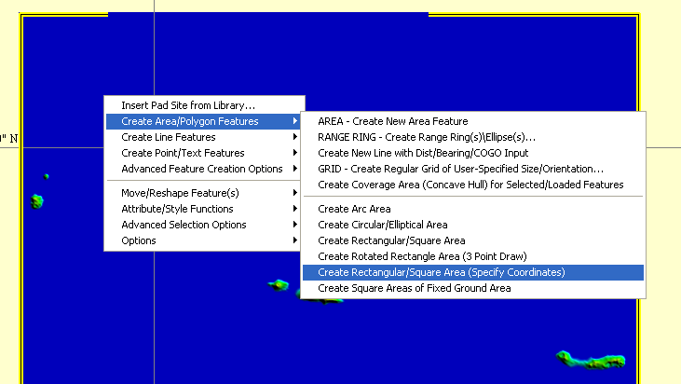

Select parameters of 2 next windows and click ok on both. (Do not enter name on 2nd window)

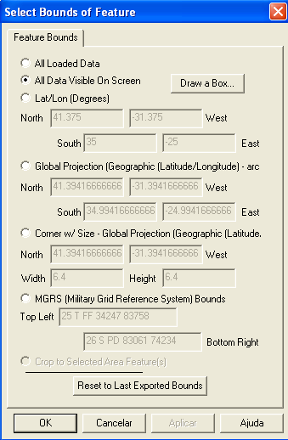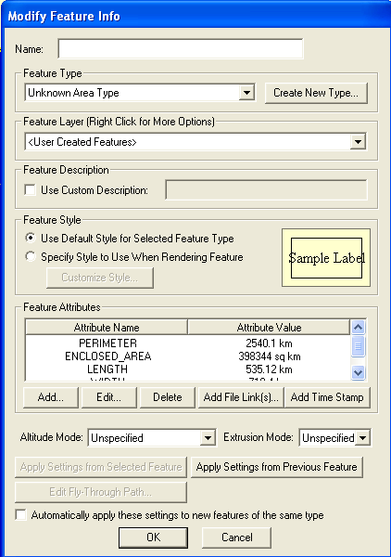
Now, the selection is ready to save.
4.2-) Save the area selection:
FILE – EXPORT – EXPORT VECTOR / LIDAR FORMAT – Export like SHAPE FILE – Click OK.
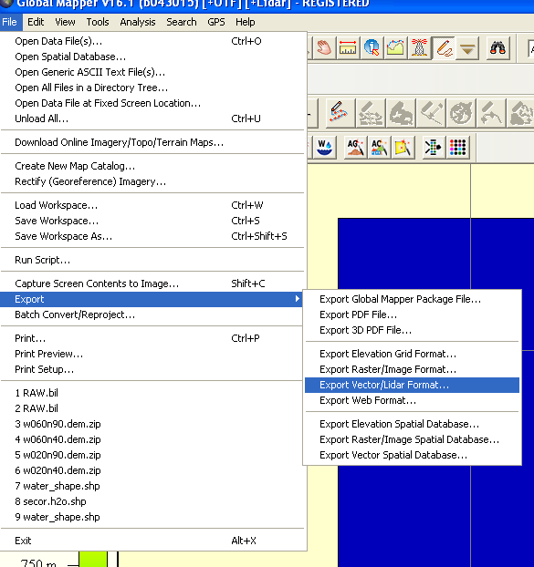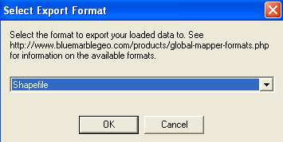

Click ok on next TIP window. On Shapefile Export Optins t window, enable EXPORT AREAS box and click SELECT FILE… button
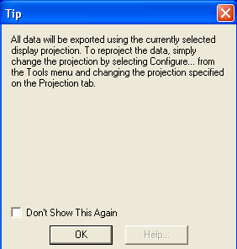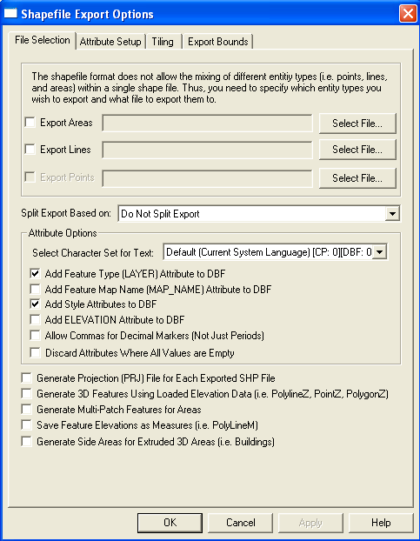

Save with a name like Total_Area.shp on your working directory. Click on Save button. Click OK button.
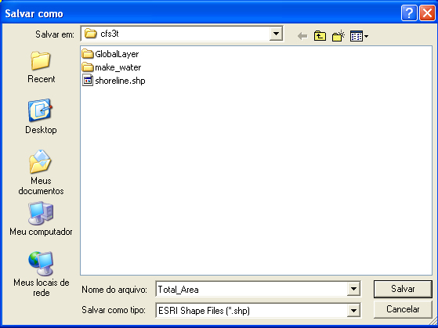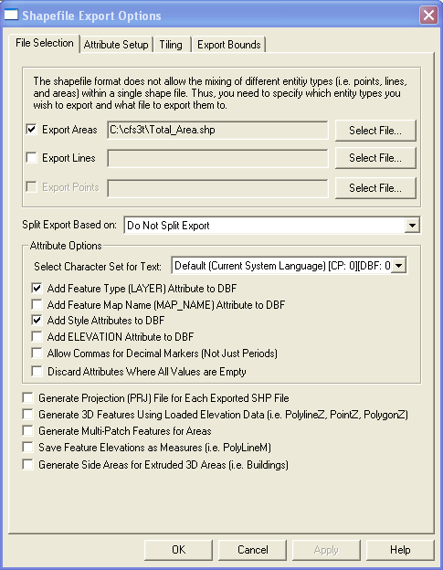

Now, you have the required files to generate the water shape file. Close the GM.

4.3-) Check your working directory. It look like this (with shoreline and Total_Area files):
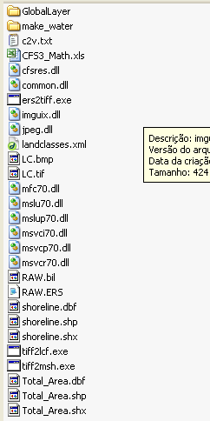

4.4-) The Water shape file.
The Water shape is a file with AREAS shapes of all large water areas like ocean, lakes and big rivers.
To do this, you need to subtract the land areas from a total area of water. Follow the steps carefully.
Open the QGIS Desktop software. Open your working directory on navigator area. Search for shoreline.shp and open it with a mouse double click.
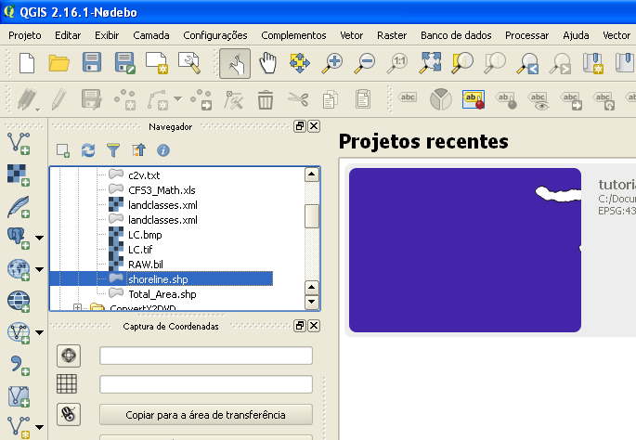
Note on the LAYER region, the SHP files opened. Also, note the vertical line (longitude ref.) generated by GM.
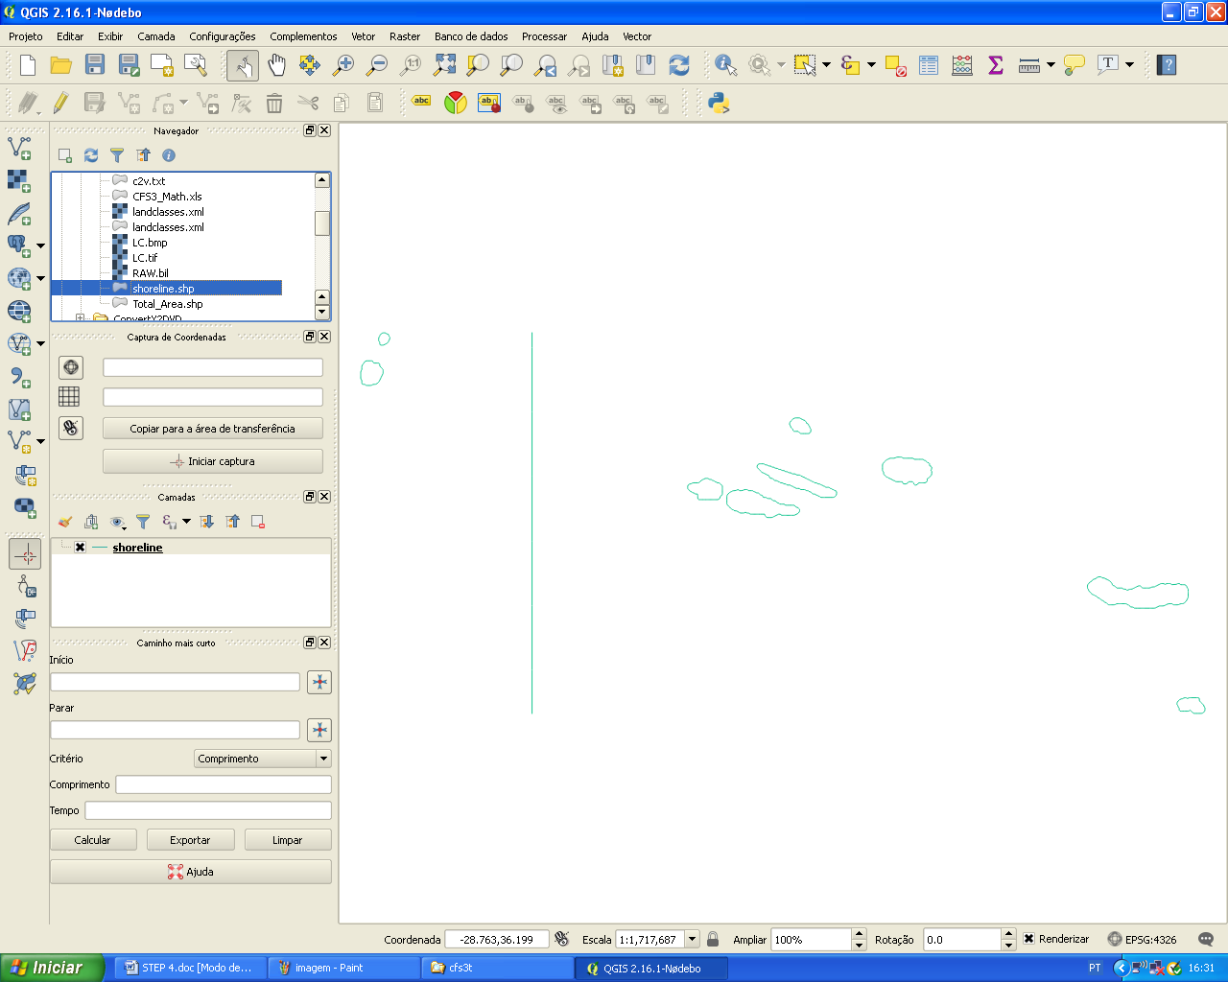

To delete the longitude line, enable the EDIT mode. After this, enable the NODE TOOL:
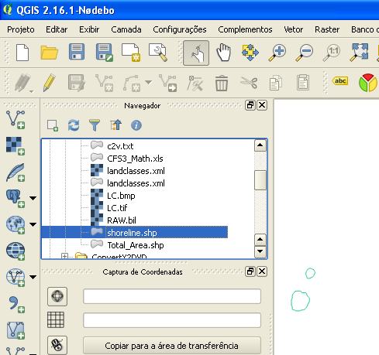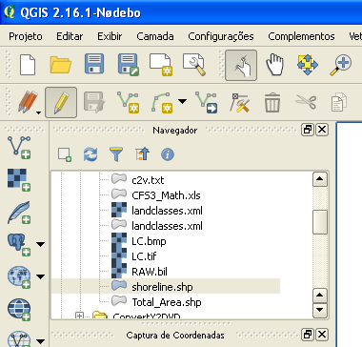

Click on any point in the line to select it. Select the line ZERO on the points table (left lower corner) and press DELETE on your keyboard until all points were all deleted.
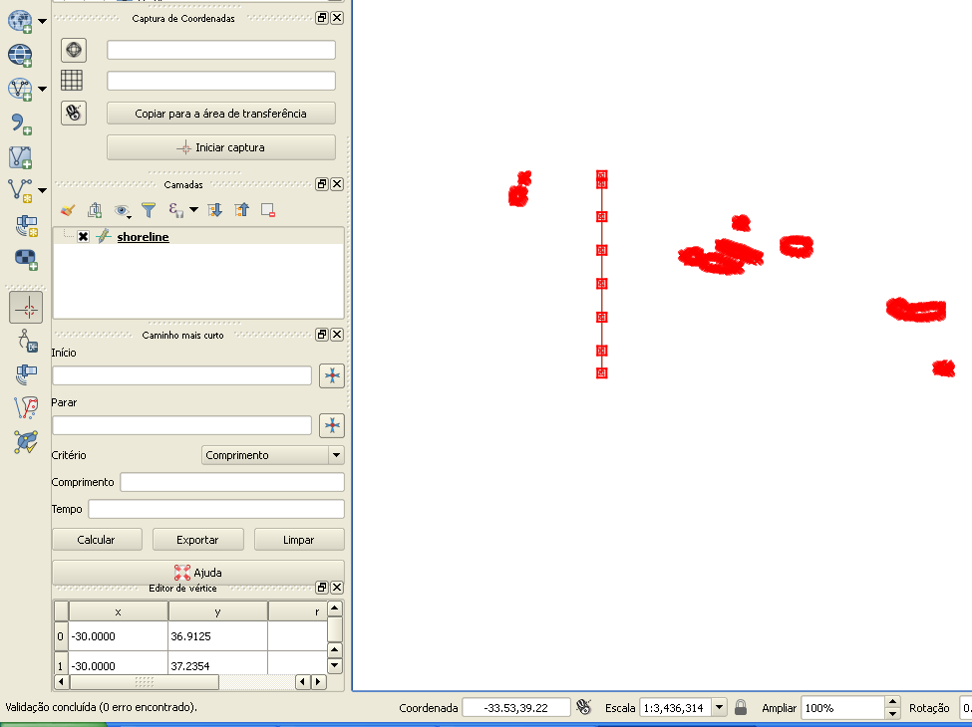
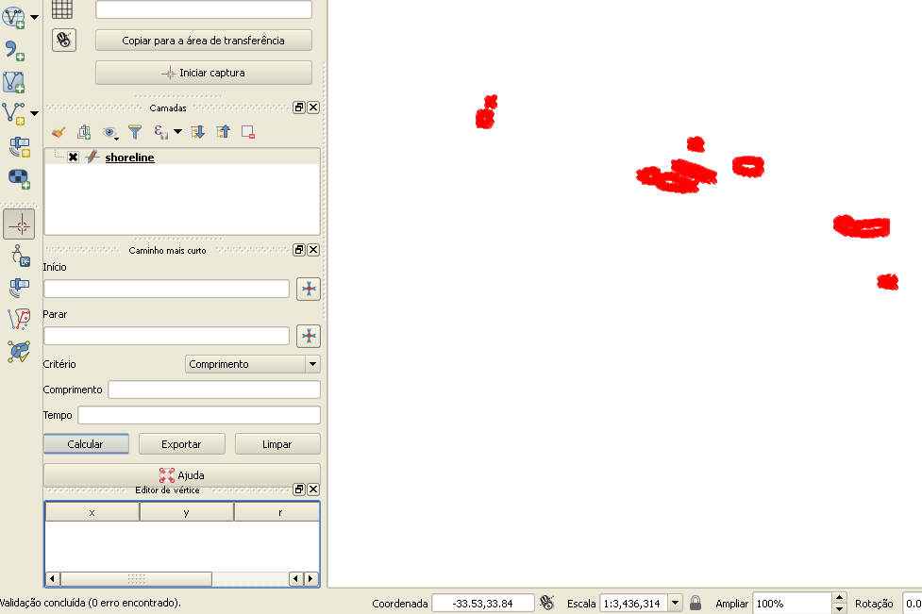
Now, you must to prepare the shoreline.shp for closed lines to area transformation: MENU LAYER – OPEN ATTRIBUTE TABLE
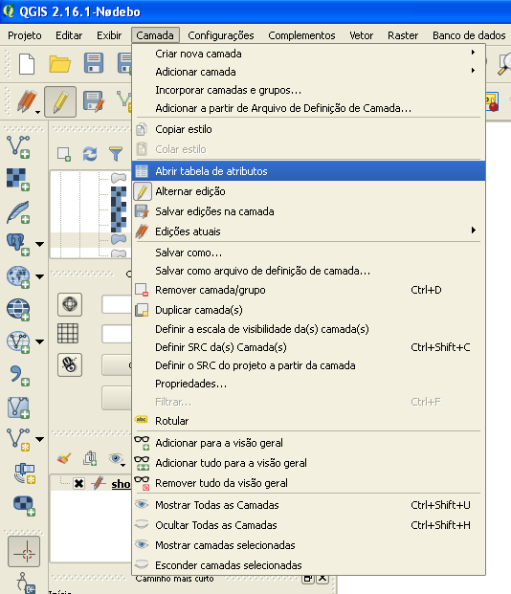

Select the 1st line (header) and delete it. The edit mode must be enabled.
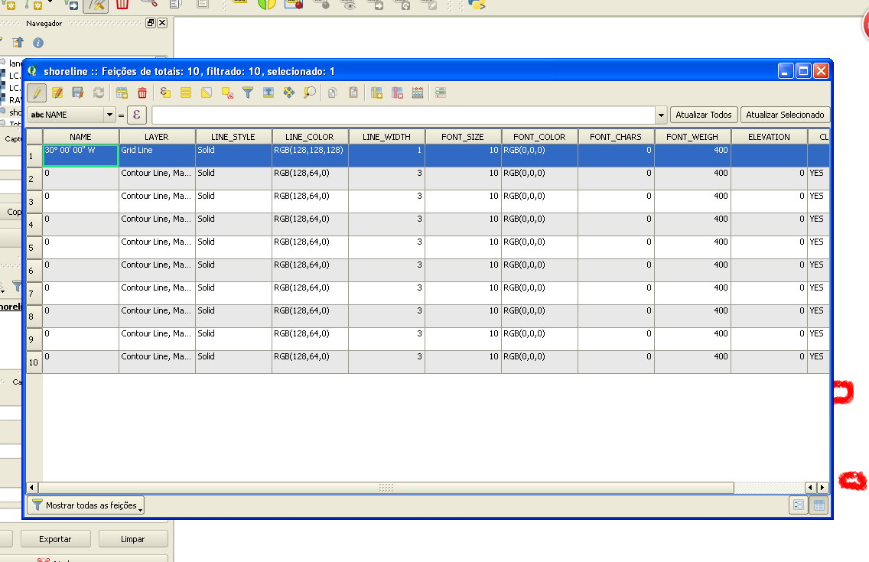
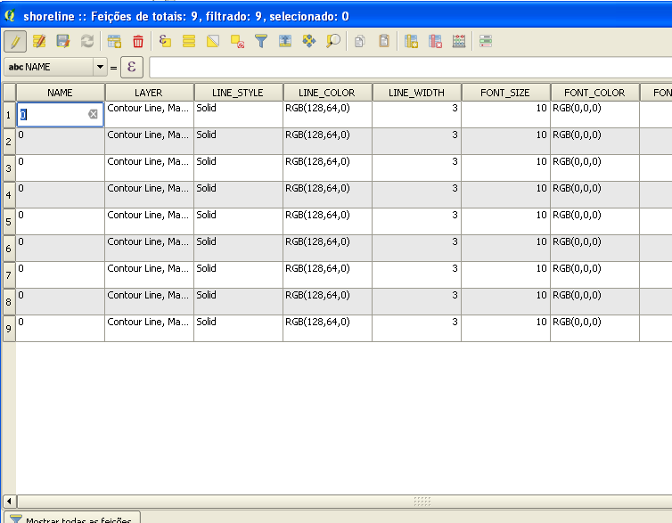
Close the Layer features window.
Disable the edit mode and SAVE the modifications on shoreline.shp file.
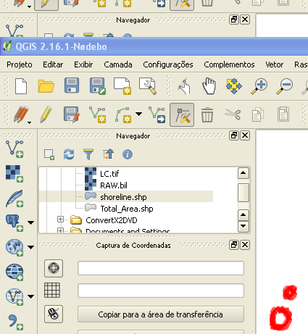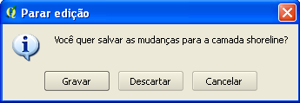

4.5-) Line to polygons transformation – Closed lines to areas: MENU VECTOR – LINE TO POLYGONS

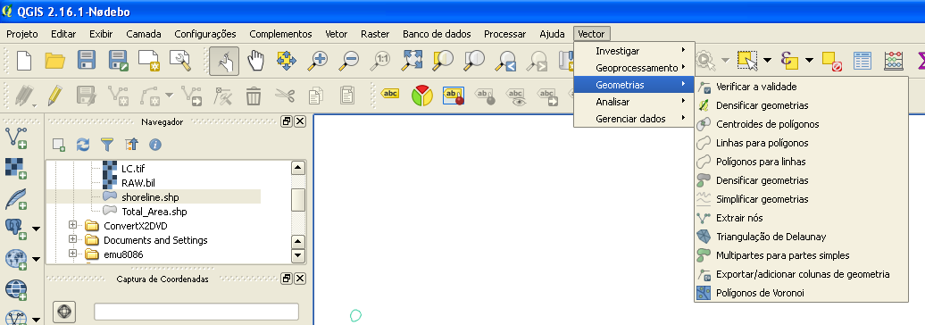

Check the parameters and click on RUN (QGIS will generate a temporary file).
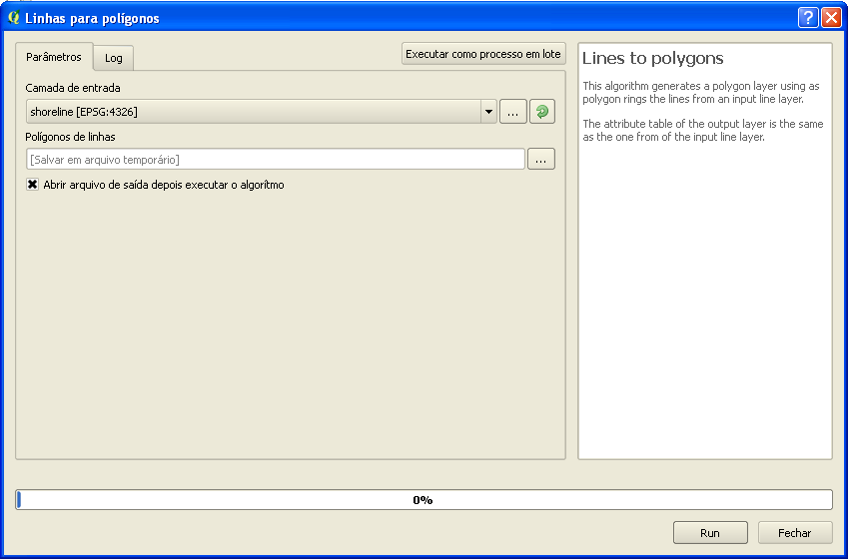

Note the new layer with islands filled. Now, this is an area shape.
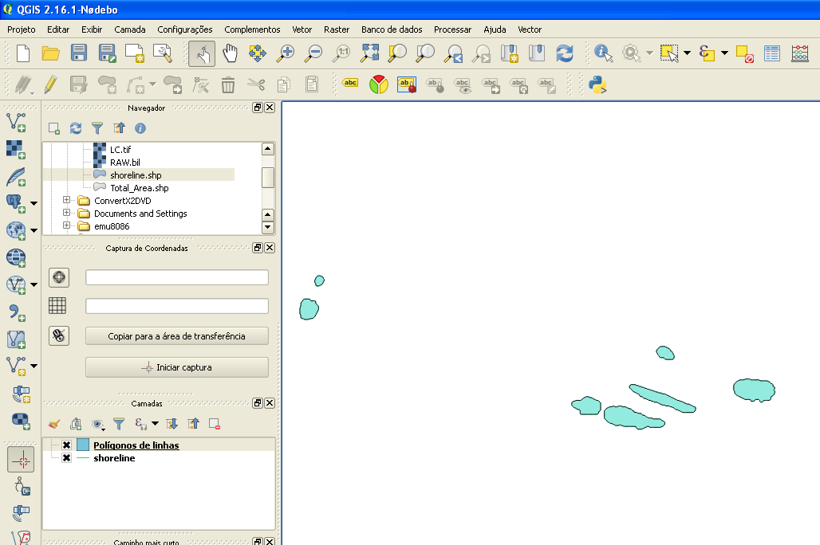

4.6-) Open the Total_Area.shp file as new layer. Double click on Total_Area.shp file in Navigator.
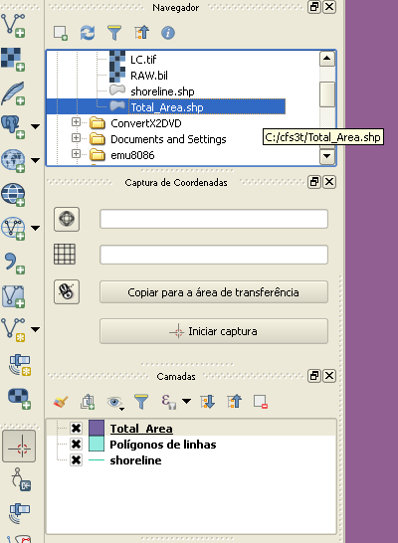
4.7-) Water Shape generation: MENU VECTOR – DIFERENCE (SUBTRACT)
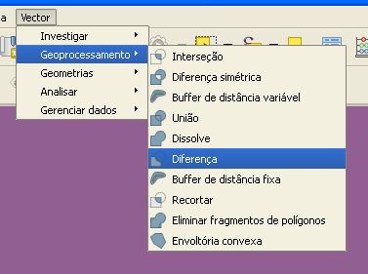

Change the parameters like the following image. Click on RUN button.
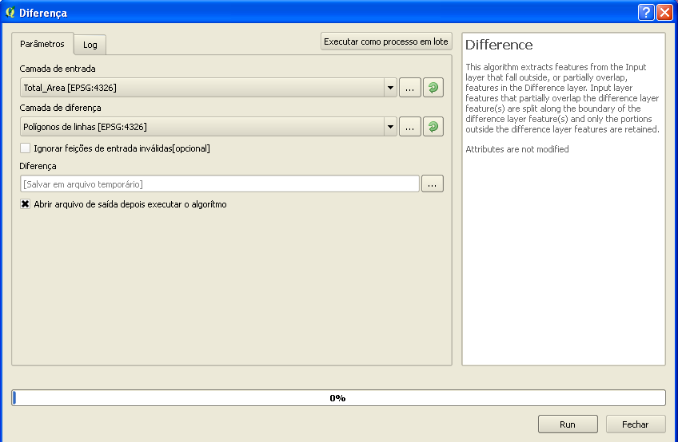

Finally, the water shape was generated. To see, turn off the others layers.
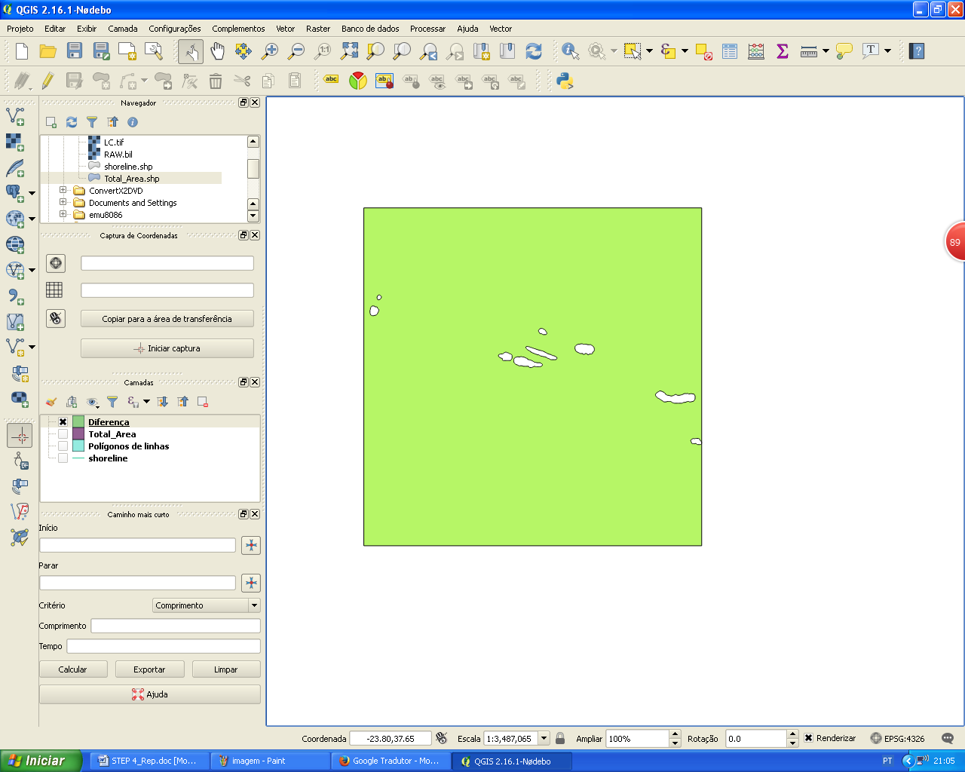
Save the Water Shape. Right click on generated layer. A pop-up menu will appear: SAVE AS…
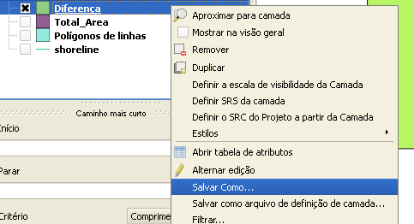

Click on SEARCH button to select your working dir.
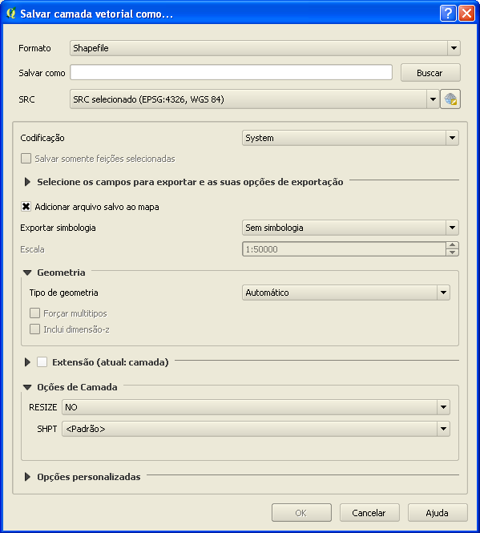
Name it like WATER. Click on Save button
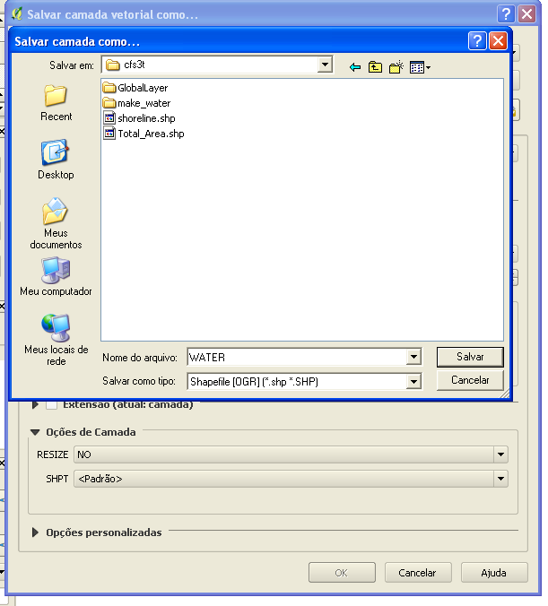

Check the path and click on OK button.
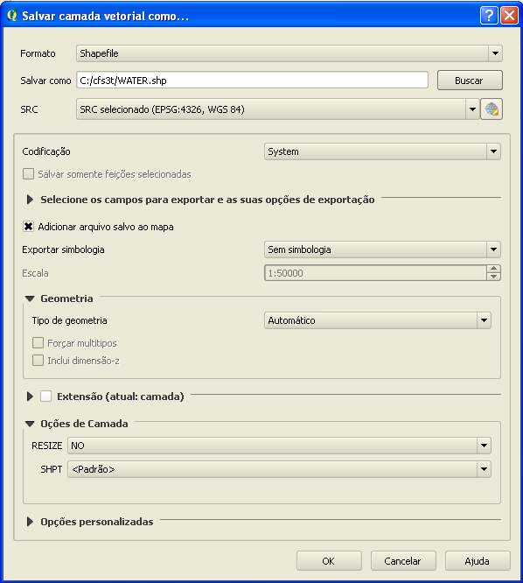
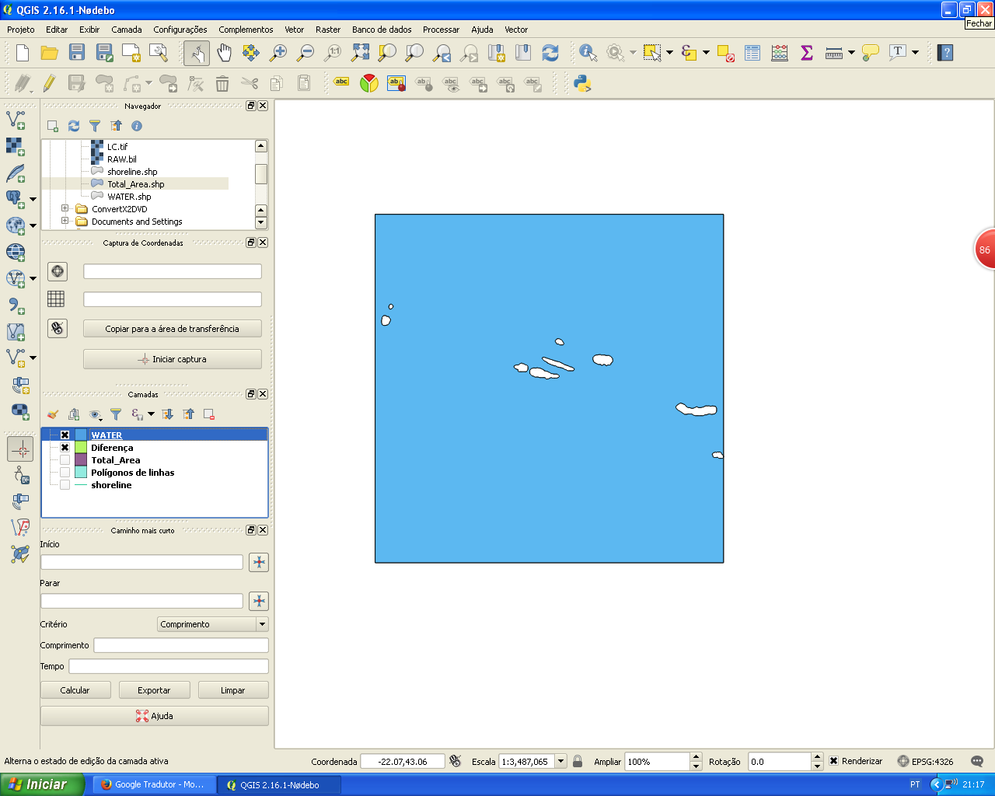

Close the QGIS. You do not need to save the project. The WATER.shp is already saved.

4.8-) Now, all files required to produce a basic CFS3 Theater were ready. Your working dir must be like following image:
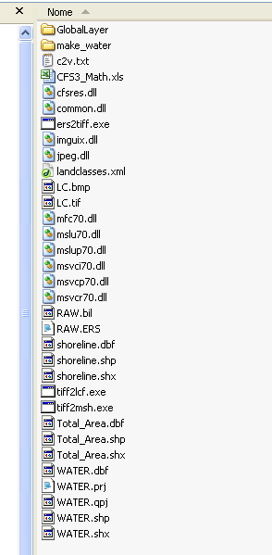
For Landclass tool
For Mesh tools
For shoreline tool
For water tool

4.9-) END OF STEP 4

